About Northwest Federal

Northwest Federal:
- is headquartered in Herndon, Virginia and was chartered in 1947
- has in excess of $3.6 billion in assets and is the third largest credit union in Virginia with over 270,000 members and 550+ employees
- has field of membership that includes several government agencies, 600+ member companies in the Northern Virginia area, 32 community partner organizations as well as family and household members of these groups

Northwest Federal's:
- Mission is to create quality financial relationships for a lifetime by providing valuable financial products and services that exceed members' expectations
- Vision is to be the lifetime financial partner for our member-owners
- Why is “Together, we serve and inspire to transform lives”

Northwest Federal offers full service banking including:

- Savings & Checking Accounts
- Youth Club Accounts
- Mortgage/Equity Loans
- Auto Loans
- Credit Cards
- Personal Loans
- Free Online Banking, Mobile Banking and Bill Pay
- Free Financial Counseling
- Business Services and Loans
- Network of 33,000+ free ATMs

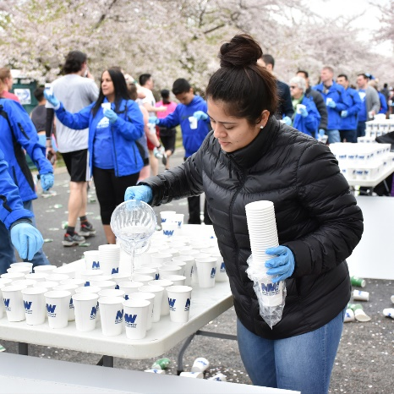
At Northwest Federal, we strive to provide more than great service. We're dedicated to transforming the lives of our members and our communities through our “Transforming Lives Through Acts of We” community service initiative.

In 2018 employees volunteered over 7,800 hours and we donated over $120,000 to our Community Partners.

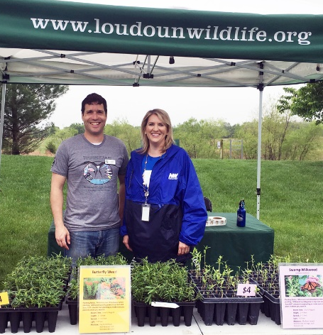
Additionally, our Northwest Federal Credit Union Foundation has awarded over $1.4 million in college scholarships to 284 recipients since the program’s inception in 2005 and partners with local schools to provide mentoring and youth outreach programs.

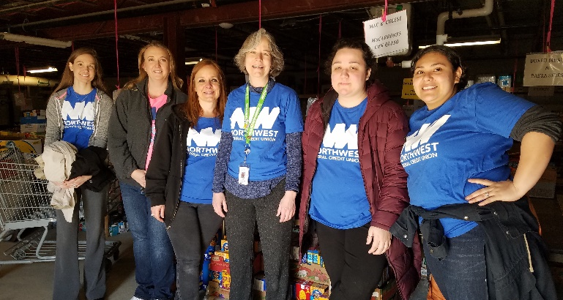

Recent Philanthropic News
Northwest Federal Credit Union Foundation Awards $150,000 in Scholarship Money
Northwest Federal Credit Union’s charitable arm, the NWFCU Foundation, recently awarded $150,000 in scholarships to college-bound individuals, including $20,000 to Northern Virginia Community College for their “Lifeline Grant,” an emergency relief fund for students on their campuses.

Northwest Federal Wins Mastercard’s “Doing Well by Doing Good” Award
Northwest Federal Credit Union was recently recognized by Mastercard for its philanthropic work as part of their 2019 Community Institution Segment Awards.

Northwest Federal Credit Union Launches Financial Wellness Program
Northwest Federal Credit Union recently introduced their new Financial Wellness Program by conducting a free seminar at the Herndon Senior Center in Herndon, Virginia.

Northwest Federal Donates $10,000 to Friends of Homeless Animals
Northwest Federal Credit Union donated $10,000 to resurface exercise runs for shared kennels at the Friends of Homeless Animals (FOHA) shelter as their final donation for 2018.

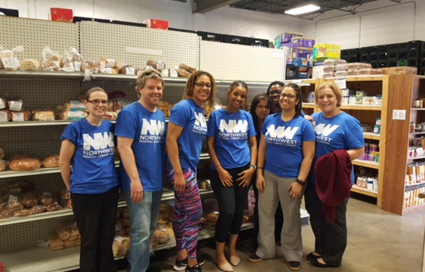 | 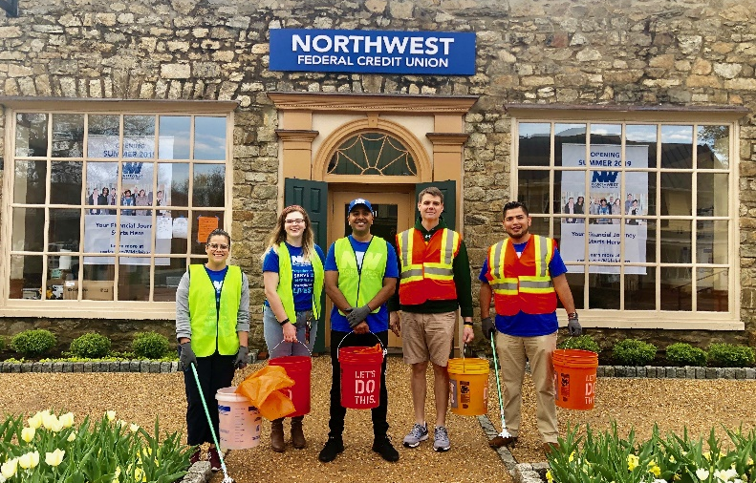
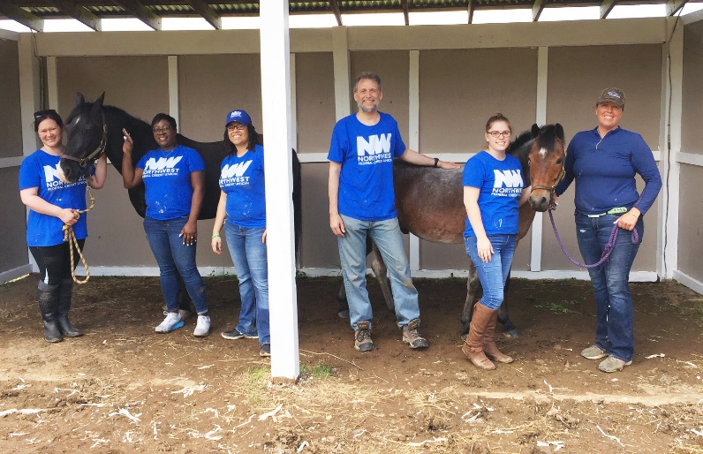 | 